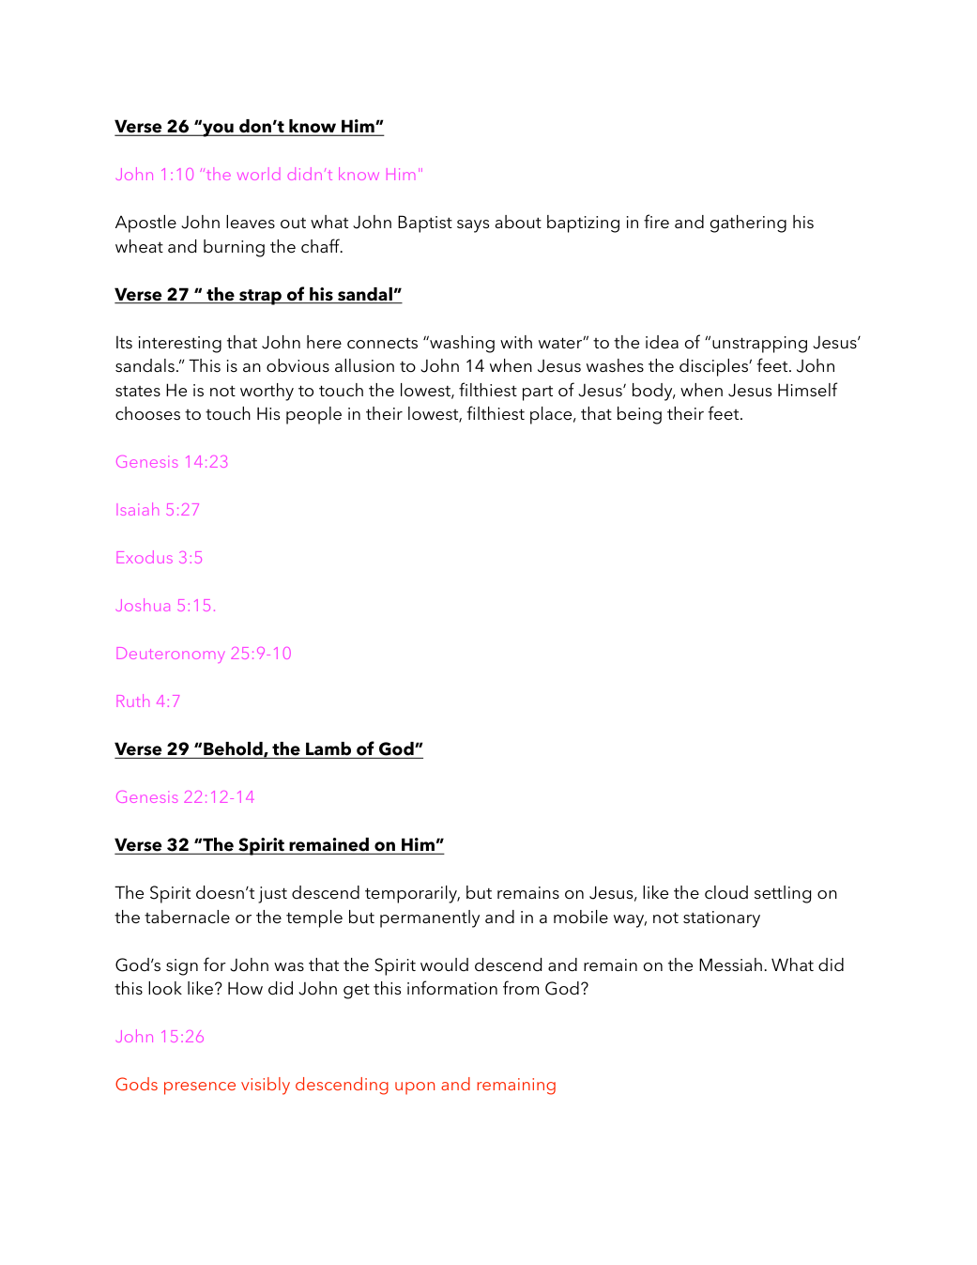
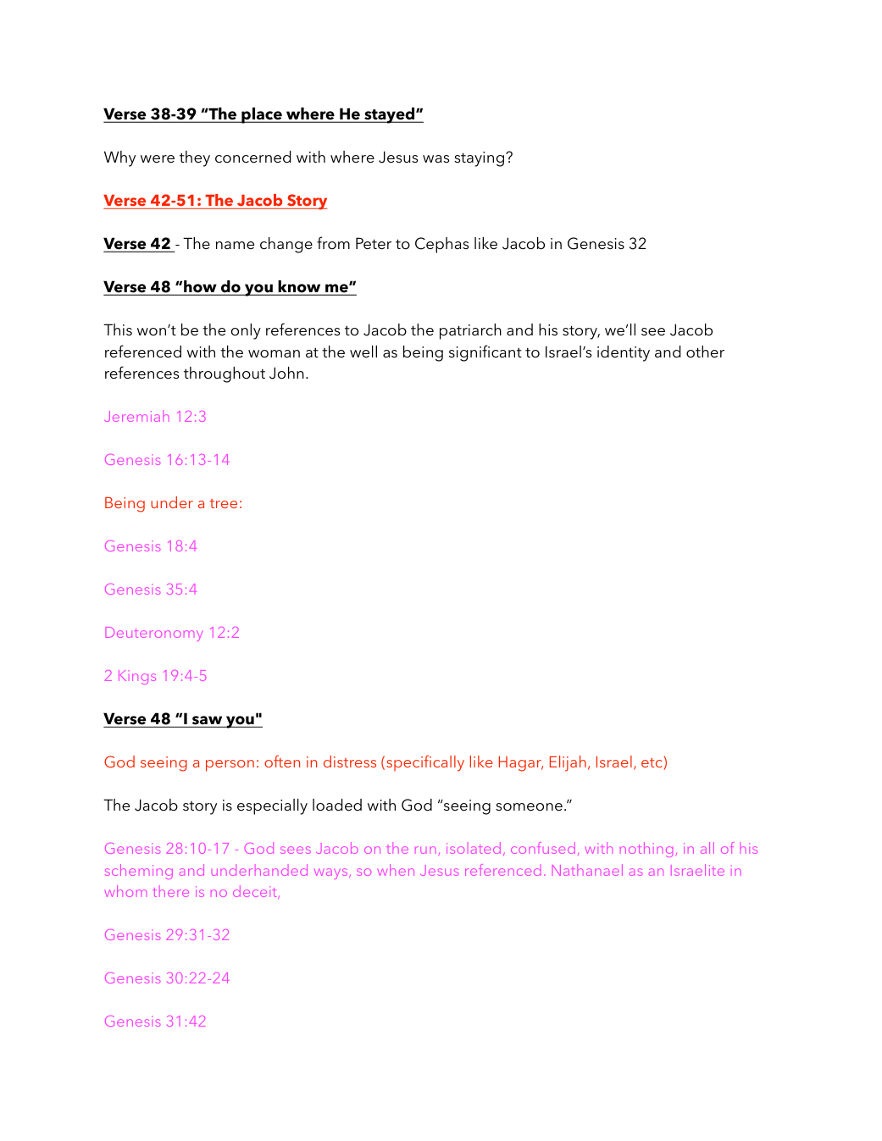
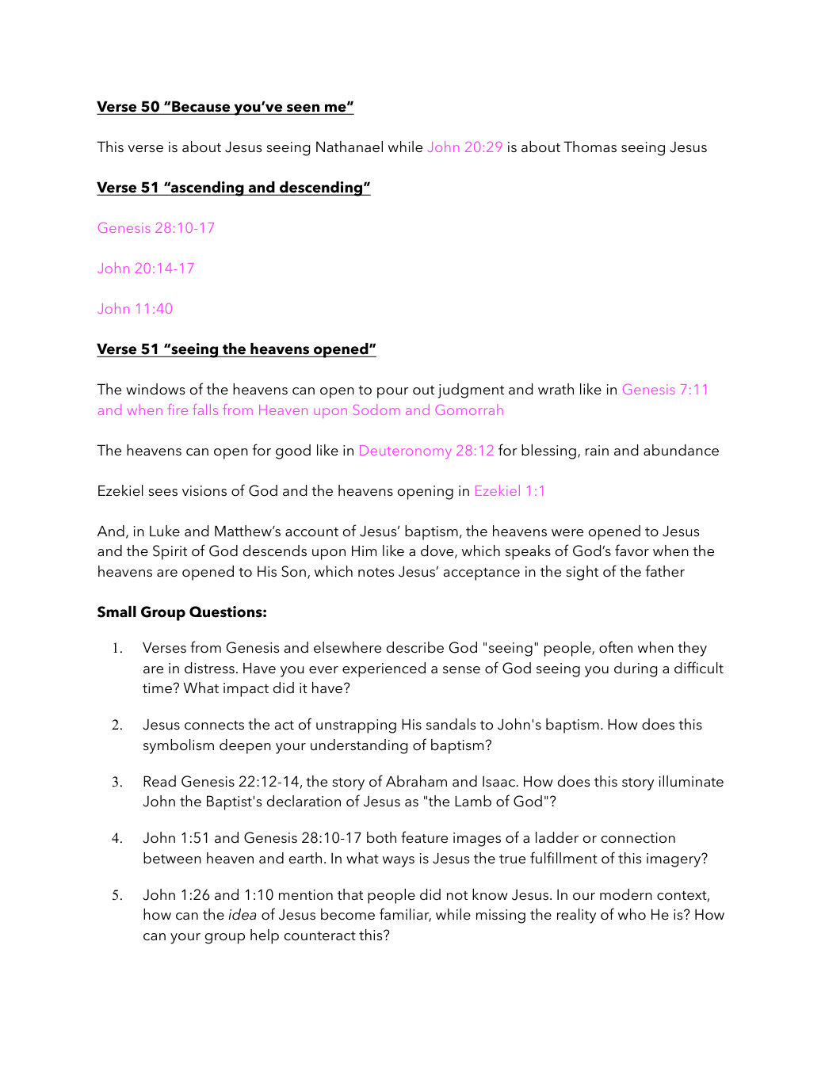


SMALL GROUP & PERSONAL STUDY
JOHN 1:19-51 - BEHOLD THE LAMB OF GOD
SMALL GROUP DISCUSSION QUESTIONS
1. How does John preparing the way and witnessing to Jesus shape the main message of this passage? (John 1:23,29-34)
2. Why is Jesus as God's provided Lamb important for understanding what Jesus is revealing? (John 1:29)
3. What does the Spirit remaining on Jesus teach us about faith, discipleship, or the character of God? (John 1:32-34)
4. How does Jesus seeing and knowing Nathanael connect this passage to the larger story of Scripture? (John 1:47-49)
5. What would it look like for a group of believers to live out Jesus joining heaven and earth together? (John 1:51)
PERSONAL REFLECTION QUESTIONS
1. Where do I most need to respond personally to John preparing the way and witnessing to Jesus?
2. What assumption, fear, desire, or habit could keep me from embracing Jesus as God's provided Lamb?
3. How clearly is the Spirit remaining on Jesus visible in my own life right now?
4. What would change this week if I took Jesus seeing and knowing Nathanael more seriously?
5. What specific step can I take to grow in Jesus joining heaven and earth?
APPLICATION POINTS
1. Build your life around John preparing the way and witnessing to Jesus. John 1:23,29-34
2. Practice Jesus as God's provided Lamb. John 1:29
3. Respond faithfully to the Spirit remaining on Jesus. John 1:32-34
4. Keep returning to Jesus seeing and knowing Nathanael. John 1:47-49
5. Let your choices reflect Jesus joining heaven and earth. John 1:51
CROSS-REFERENCE PASSAGES
1. John 1:29 - This passage reinforces the central biblical image or argument and is useful for deeper group study.
2. John 1:32-34 - This passage develops the same theme from another angle and is useful for deeper group study.
3. John 1:47-49 - This passage connects the passage to the wider biblical storyline and is useful for deeper group study.
4. John 1:51 - This passage helps translate the theme into faith and discipleship and is useful for deeper group study.
5. John 1:23,29-34 - This passage brings the main emphasis back into focus and is useful for deeper group study.

